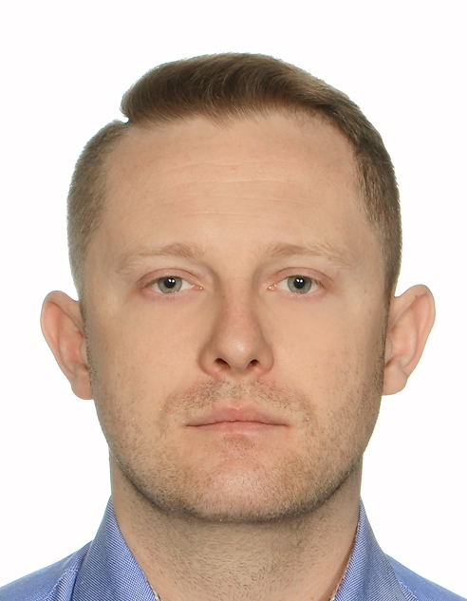
Marcin Lysiak
23 Upper Dicconson Street
Wigan WN1 2AG
+44 07380669758
mlysiakk@gmail.com

I am a Site Manager by education with 6 years of experience. In United Kingdom, I have been working as a general laborer and site engineer assistant, preparing my documents and improving my language. After my study in Poland at Kielce University of Technology, I gained the various of experience in many companies from different countries. I supervised all phases of construction from earthworks to finishing works. I was also responsible for Occupational Health and Safety. (OHS). Now, because of personal reason I am moved to Wigan and I am looking for work as a

Site Manager Assistant.

PROFESSIONAL EXPERIENCE:

Renaker Build Ltd, Manchester, Site Engineer Assistant, September 2022 -
Minstrell Recruitment Limited, General Laborer, October 2020 – September 2022
Atlas Ward Polska, Wroclaw, Site Manager, January 2018 – November 2019
Rafbach, Leg Tarnowski, Site Manager, October 2018 – January 2018
Mostostal Krakow, Krakow, Site Manager, November 2017 – October 2018
Lloyd Acoustics, Lysakow Drugi, Site Manager Assistant, September 2017 – November 2017
EM-BUD, Zabrze, Site Manager Assistant, April 2017 – May 2017
BREMER AG, Krakow / Paderborn, Site Manager Assistant, November 2016 – March 2017
BS Construction, Kielce, Site Manager Assistant, May 2016 – October 2016
DORBUD, Kielce, Site Manager Assistant, August 2015 – November 2015
WIG Constructions, Kielce, Site Manager Assistant, July 2014 – October 2014

KEY DUTIES & RESPONSIBILITIES:
- supervising the progress and quality of construction works,
- cooperation and supervising subcontractors works
- ability to read technical drawings
- calculation and ordering of concrete
- knowledge of works: groundworks, concrete works, assembled works, finishing works,
- basic level of knowledge for using Electronic Distance Measurement
- taking a part in organizational meetings,
- preparing reports on the construction process,

EDUCATION:
Master of Science, Engineer, Kielce University of Technology, Civil Engineering, 2011 - 2013
Specialization: Construction Technology and Organization.

Engineer, Kielce University of Technology, Civil Engineering, 2008 - 2011

ADDITIONAL STUDY AND COURSES:

- Occupational safety and health, post-graduate studies,
- Pedagogical training course for instructors of professional training and lecturers,

ADDITOINAL SKILLS:  - White CSCS card,  - British driving license,  - MS Office,  - AutoCAD,  - Norma Pro, | LANGUAGES:  Polish - Native  English - Advanced  German - Basic

REFERENCES:

- Mark Callaghan – Frame Project Manager,
Mobile: 07936032054, E-mail: MarkCallaghan@renaker.com RENAKER
- Daniel Bunyan – Senior Engineer,
Mobile: 07873628817, E-mail DanielBunyan@renaker.com RENAKER
- Justin Wilde – Senior Site Manager,
Mobile: 07872 800849, E-mail: Justin.Wilde@ates.co.uk Wates

INTERESTS AND HOBBIES:

Traveling, fishing, sports

I agree to the processing of personal data provided in this document for realizing the recruitment process pursuant to the Personal Data Protection Act of 10 May 2018 (Journal of Laws 2018, item 1000) and in agreement with Regulation (EU) 2016/679 of the European Parliament and of the Council of 27 April 2016 on the protection of natural persons with regard to the processing of personal data and on the free movement of such data, and repealing Directive 95/46/EC (General Data Protection Regulation)”

