Mr Stephen Fairhurst

2 Davis Drive

Amble

Morpeth

Northumberland

NE65 0QN

Dear Sir/Madame

I am writing to apply for the role of Assistant Manager Please find attached a copy of my CV.

As you can see from my CV, I have valuable experience working as an Assistant Manager/Engineer. At my previous company I was a key member of the team and proved myself to be an assertive and effective leader who is able to manage and motive others. I am able to multitask and manage my time to ensure high standards and performance targets are always met.

I am a confident, organised and professional individual with a limitless drive to be successful and exceed expectations. I have excellent communications skills meaning that I find it easy to develop a sense of rapport with colleagues and clients alike.

I work effectively in a team and manage people in an organised and professional manner, leading by example. I also work well independently and under pressure in a fast-paced business environment.

With my experience and business expertise, I strongly believe that I would be an asset for your team.

Thank you very much for considering my application. I look forward to hearing from you,

Yours sincerely

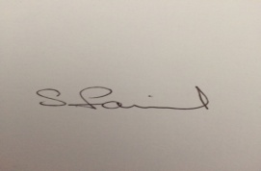

Stephen Fairhurst

07943311342