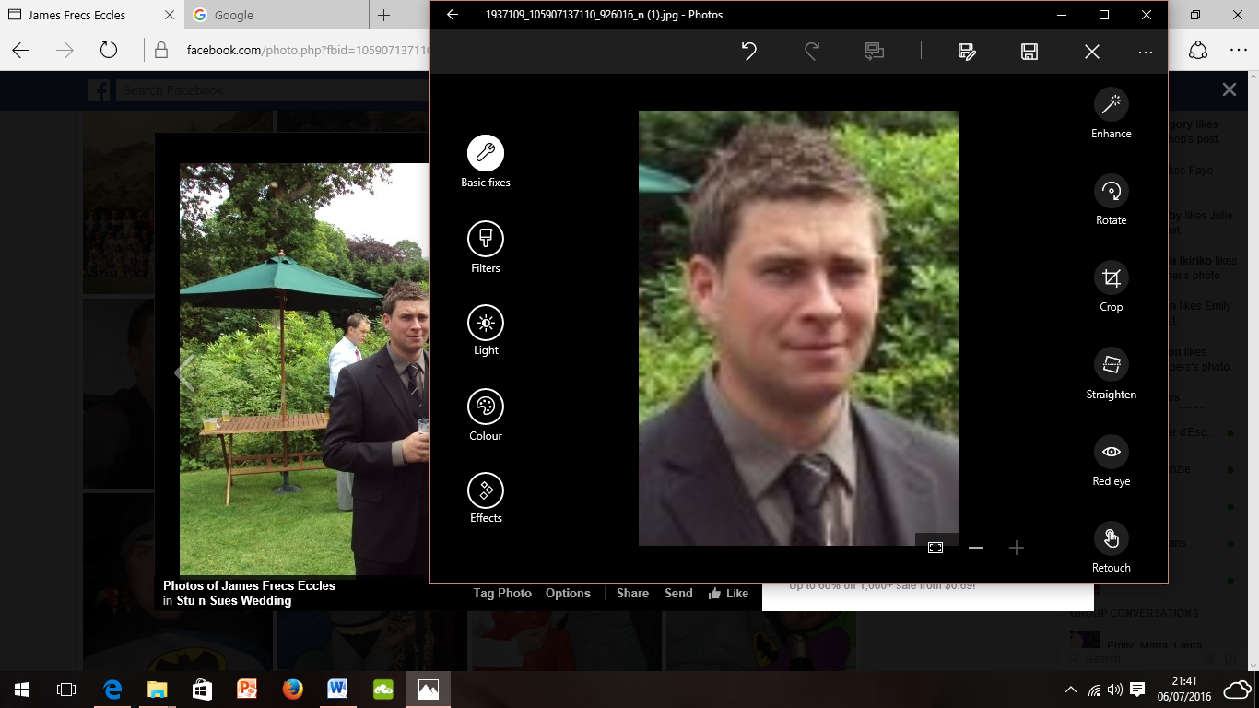**James. R. Eccles**

25 Melbourne Road, Carlisle, Cumbria, CA1 2DW

**Mobile**: 07802216702

**Home**: 01228 490226

**Email:** jameseccles666@yahoo.co.uk

Personal statement

Experienced construction foreman, with over ten years’ experience in residential and commercial construction. Currently working with Cumbria County Council Highways and specialising in construction projects in the Highways sector. Responsible, reliable professional with expertise in all aspects of building, and managing general construction projects including material estimates, subcontractors and labourers. Proven track record in utilising specialist experience to train employees under my supervision ensuring appropriate use of equipment, arranging materials and equipment to be at construction sites, evaluating and communicating plans for each construction job, I am currently seeking new challenges. Challenges that will provide the opportunity to engage my drive and enthusiasm to see a project through, utilise my meticulous attention to detail, and friendly, professional manner. I am looking for the right opportunity to bring my expertise to a well-established construction company in a site management position.

Key Skills

Through on-going professional review the following have been identified as key skills and strengths;

* Secure knowledge of the building trade, including stonemasonry
* Committed to my on-going professional development, skills and abilities in the construction and engineering sector
* Good at building positive relationships with others including those under my supervision, local authorities, subcontractors and the general public
* Team player and I lead by example
* Problem solver with the ability to use my own initiative to tackle tasks
* Excellent communication skills, both written and verbal
* Trustworthy, proactive and tenacious in my approach to professional tasks

Employment History

Cumbria County Council Highways

(August 2017– Present)

* Planning and organising own and teams work to meet given priorities.
* Monitoring performance and allocating workload within team on a day to day basis.
* Work is completed on time, and to set standards.
* Discussing work method; receiving and clarifying instructions for the team from supervisor and manager. Organising and co-ordinating the work of employees.
* Responsible for implementing some Human Resources procedures in the area, including performance and attendance management and appraisal and assisting with discipline and recruitment.
* Teamwork is well organised.
* Human Resources issues are dealt with effectively, or escalated.
* Supervising, developing and motivating a team

The Environment Agency

(January 2010 – December 2016)

Achievements and responsibilities:

* Planning of site packs including; health and safety considerations and analysis, job and location specific method statements, equipment and materials required, implicated services and utilities, risk assessment, liaising with management about specific site requirements
* Supervision of teams of individuals working on sites. Tailoring individual team members’ strengths to suit tasks on site.
* Ensuring jobs are completed on time, on budget and in line with Environment Agency protocol and standards
* Supervision of contractors and regional aid (for example during Storm Desmond)
* Operation of and supervision of machinery and equipment on site
* Using technology to create and complete professional site packs
* Liaising with outside agencies such as local authorities, subcontractors and the general public
* Communicating the goals and acting as a point of contact for the environment Agency whilst on site
* I recently achieved at Higher National Certificate in Construction for the built Environment and completed this with distinction.
* I obtained the position of Lead Team Member which afforded me the opportunity to lead and manage tasks

Eric Wright Construction

(March 2007– January 2010)

Achievements and responsibilities:

* Using planning documentation to mark out planned measured and accurate boundaries for future construction projects
* Taking core samples of earth to test ground stability
* Ensuring sites were operating in an orderly fashion to ensure health and safety requirements
* Surveying and measuring ground levels to ascertain the shape of the land and gathering data for construction projects
* Assisting and working with trades personnel to complete individual projects on site
* Using plant and equipment to carry out ground works effectively and safely
* Involvement in tool box talks before operations on site began
* Ensuring sites remained secure and controlling authorised access to site in line with health and safety requirements
* Site inductions including communicating with new personnel about site layout, cross-checking documentation for new contractors and staff
* Participated in the successful completion of the Furness College construction project on time and on budget
* Participated in the successful completion of a project where sustainability and the environment were key considerations of the client. This fifty four week project resulted in a new facility incorporating both rainwater water harvesting and solar heating. The completed project included the design and construction of two workshops/ office space of approximately 115,000 sq. ft.

CHC Construction

(September 2000– March 2007)

Achievements and responsibilities:

* Labouring duties, assisting trades people to successfully complete roofing projects, extension work, ground work and barn conversions
* Safe and effective use of plant and hand tools
* Mixing and laying of concrete foundations for domestic housing projects
* Using plans to site and lay drainage and sewerage pipes
* Working as part of a small hands-on team
* Ordering and checking deliveries to site
* Upon completing of projects ensuring hard landscaping was carried out to return sites to improved condition

Education

John Ruskin School, Lake Road, Coniston, Cumbria, LA21 8EW

(September 1991 – June 1996)

5 GCSEs, grade C-E, including Maths and English

Preston’s College, St Vincent’s Road, Preston, PR2 8UR

(September 2012 – June 2014)

Higher National Certificate at ***Distinction*** level in ‘Construction for The Built Environment’

Professional Qualifications

I am committed to my own professional development. Here is a sample of recent relevant training and development;

* Site Managers Safety Training Scheme (SMSTS) –***certification (4/12/2014)***
* CSCS Academically Qualified Person Card-certification scheme **(7/9/2016)**
* X63 CDM Managing Construction Acting as Principle Contractor –***certification (October 2014)***
* NVQ Level 2 in Environmental Conservation- ***certification (February 2012)***
* NVQ Level 2 in Customer Service- ***certification (February 2001)***
* Traffic management
* Emergency First Aid at Work-***certification (January 2017)***
* HGV Class 2 driving licence
* B + E licence
* 360 Excavator ***(city and guilds January 2017****)*
* Chainsaw ***(city and guilds 2017)***
* Rough terrain Telescopic Handler
* 4x4 off road trained
* Slinger/Signaller
* Lorry loader
* Lorry loader (grab)
* Hydraulic De-mountable body Equipment
* Safety of loads on vehicles
* Dump truck (rigid chassis tracked)
* Health and safety and Risk Management in Winching
* Abrasive Wheels
* Manual Handling
* Confined space awareness
* Working at height

Hobbies & Interests

I recently became a father for the first time and am enjoying and constantly learning to accommodate new family duties with my professional responsibilities at work. I am an active and motivated person and enjoy undertaking any outdoor, practical and sporting activities. In my spare time I have set a personal goal of completing the ascent of the two-hundred and fourteen peaks in the Wainwright guides to The Lake District. So far I have successfully climbed one hundred and sixty of the peaks with fifty four still to complete. I am really proud of this achievement and feel it is a good reflection of the determination and spirit of my personality. I am a keen fan of road cycling and an avid follower of The Tour de France. As such, I regularly compete in charity cycling events such as sixty mile the ‘Tour de Hawkshead’ and the fifty mile ‘Tour de Furness.’ I am looking forward to and hopeful of igniting my new born daughter’s interests in these hobbies in the future!

References

References are available upon request and further references can be furnished if needed. Please ask/contact the following;-

**Testimonial/character reference**

Miss Maria Mitchelhill

Senior Leader and Teacher,

Bellevue School,

Beaver Road,

Carlisle,

Cumbria,

CA2 7PT

Telephone: 01228 593161

Email: mmitchelhill@hotmail.com

**Professional Reference**

Environment Agency

National Customer Contact Centre

PO Box 544

Rotherham

S60 1BY

03708 506 506

enquiries@environment-agency.gov.uk

**Professional Reference**

Mr Joel Casstles

Site Manager

Mclaren

Tune Street

Shoreditch

EC2A 2DU

Telephone: 07703343086

Email: joel.casstles@mclarengroup.com